**Web Application Development**

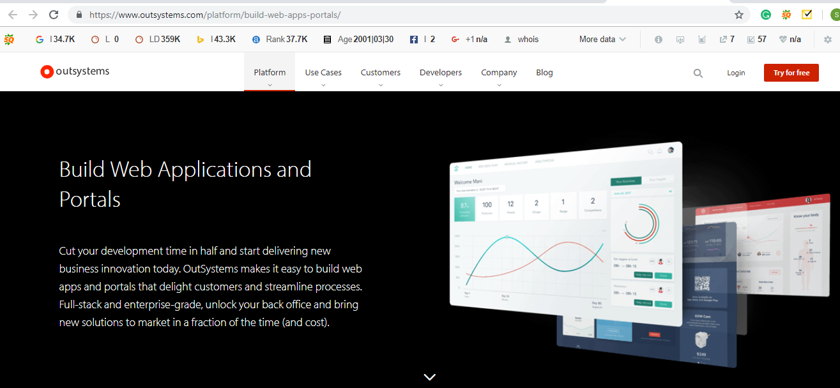

Text to be replaced

**We Can Make Your Website Better.**

**We help organizations like yours increase the effectiveness of their website while eliminating the stress and confusion of going at it alone.**

Image suggestion

<https://www.shutterstock.com/image-photo/coding-software-developer-work-ar-new-1166128429?src=HdVgksW3owGeSFxHbG4Www-1-0>

Next>>

Website page is the substance of your organization, which empowers you to connect to your target audience. The website is the most vital part of your organization's marketing plan and a central hub for your marketing efforts. All other promoting materials should support and direct audience to your site. As the website design and technology has advanced throughout the years, you presently have more digital marketing tools than ever before. Started as a Web Development company, Nunc Systems offers the best web development services by our master web developers to help improve your business objectives.

**>>**

**What makes us different?**

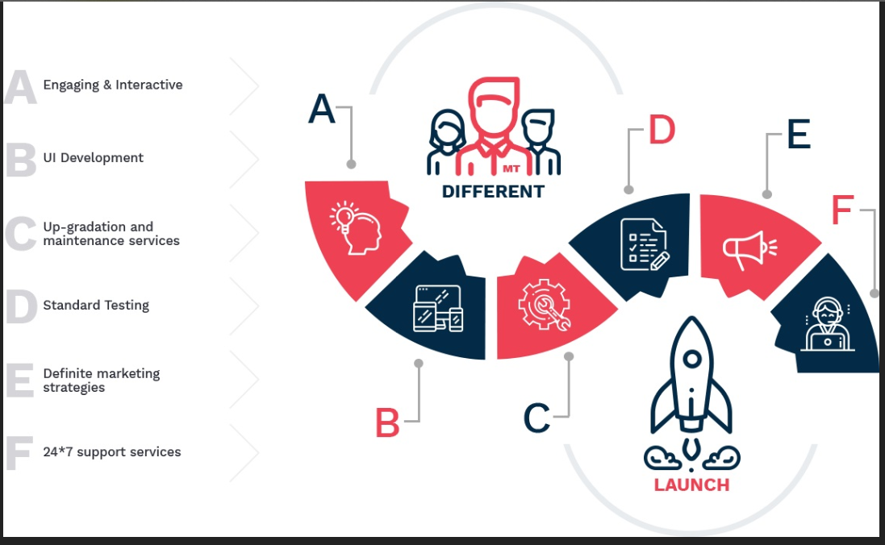

We have expert professionals who show up expertise to develop advanced systems with complex business logic dealing with large amounts of data and transactions. We are here to support you with most desirable, innovative, responsible web application and give you the lucid solution.

>>**Next**

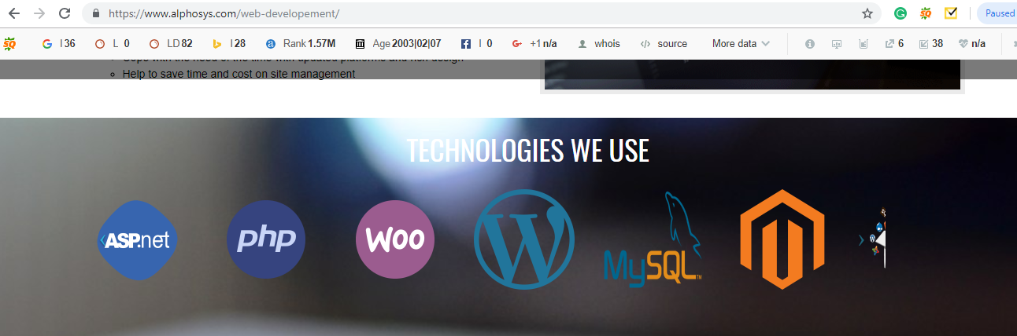

**We can mention all the technologies we use**

Our expert technical professionals and project management team will monitor you from the initial step of a business idea to implementation of a cost effective software solution. We will deliver a cherished business tool particularly intended to serve the specific needs of your business. Our main Moto is to put your business online, earn more sales and discover more leads.

>**>Next**

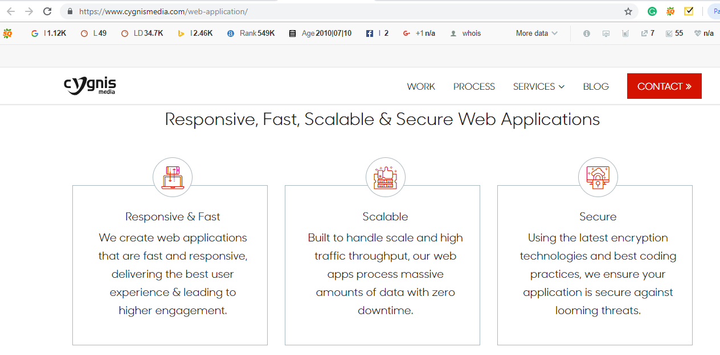

Text to be used

**Responsive & Fast**  
We develop web apps that are fast and responsive, deliver the best user experience & leads to higher engagement.

**Scalable**

We develop web app which is highly scalable and high traffic throughput, our web apps process huge amounts of data with zero downtime.

**Secure**

We use thelatest encryption technology and best coding practices, we ensure your application is secure against threats.

**>> Next>> these services we need to show as an image as show below**

Web Development Services we Offer

* Database Design and Programming
* Database Integration
* Data Importing
* Dynamic Page Creation
* Developing Web Interface for Data Entry
* Create Custom Site Engine
* Add Features to or Modify Existing Script

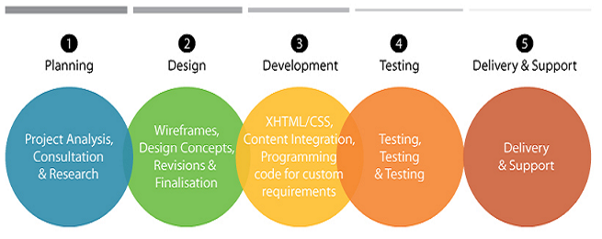

Why choose Nunc Systems Web Development Service?

1. We provide Highly Scalable module
2. We understand your business Goal & Requirement
3. Customer first approach
4. Transparent Development Process
5. Quality QA Process throughout the entire phases of the Web App Development
6. Smooth Deployment with Support & Maintenance

**Next >>**

At the **End get quotes and** Go to **“Top”** link

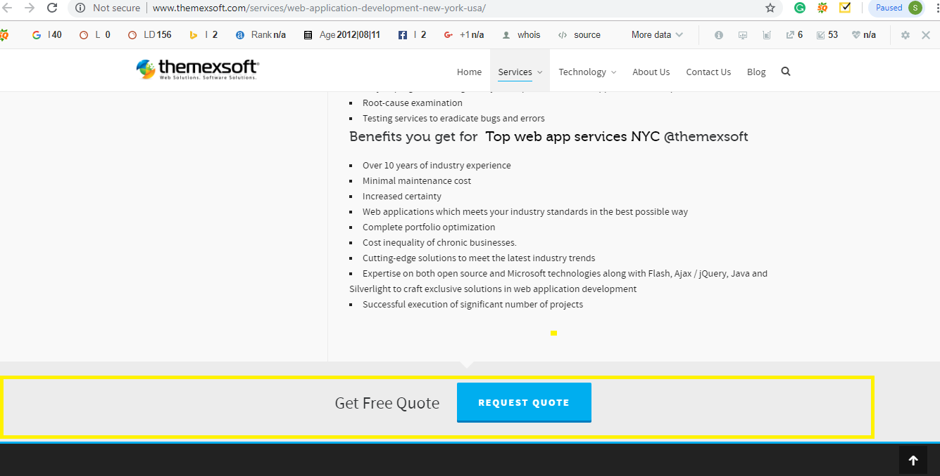

>>Footer

